DOBRO World Cup Osijek 2023.
FIG World Challenge Cup Competition
8th – 11th June 2023

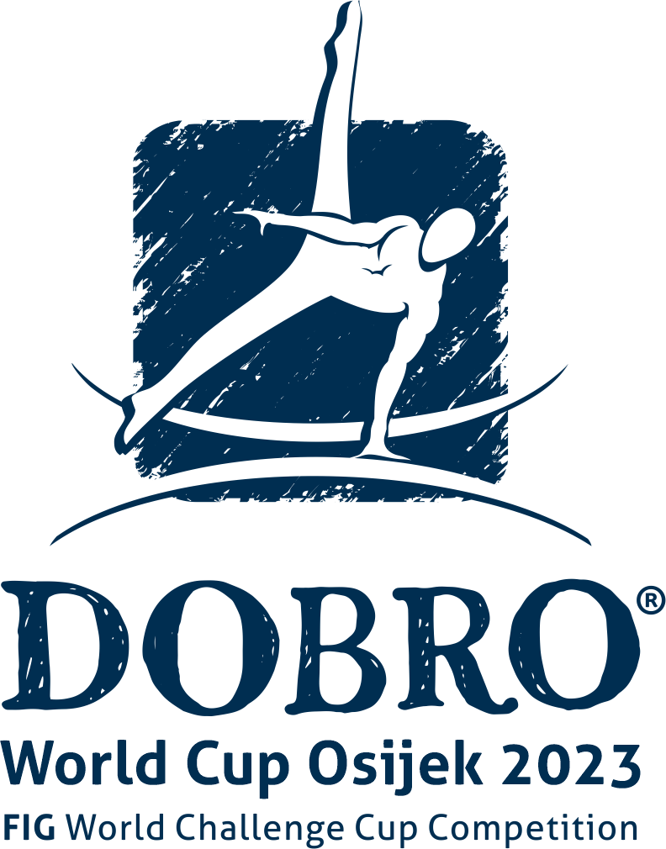

Form to be sent to:
Organizing Committee / Host Federation
booking.zito@gmail.com

Deadline: 8th April 2023

ACCOMMODATION Form

Federation |  | Contact person
 |  | Phone
 |  | E-mail

Hotel name | Room type  (single/double/triple/quadruple) | Arr. day | Dept. day | LAST NAME  First Name | Function | Gender | # of nights | Total
 |  |  |  |  |  | GRAND TOTAL

Special requirements

Place and date | Seal of the NF | NF authorised signature
 |  | Signature of the President or Secretary General of the FIG affiliated NF

